**Create a Kubernetes cluster on any cloud of your preference AWS/Azure and upgrade it to next version**

**Login to aws console and go to elastic Kubernetes service**

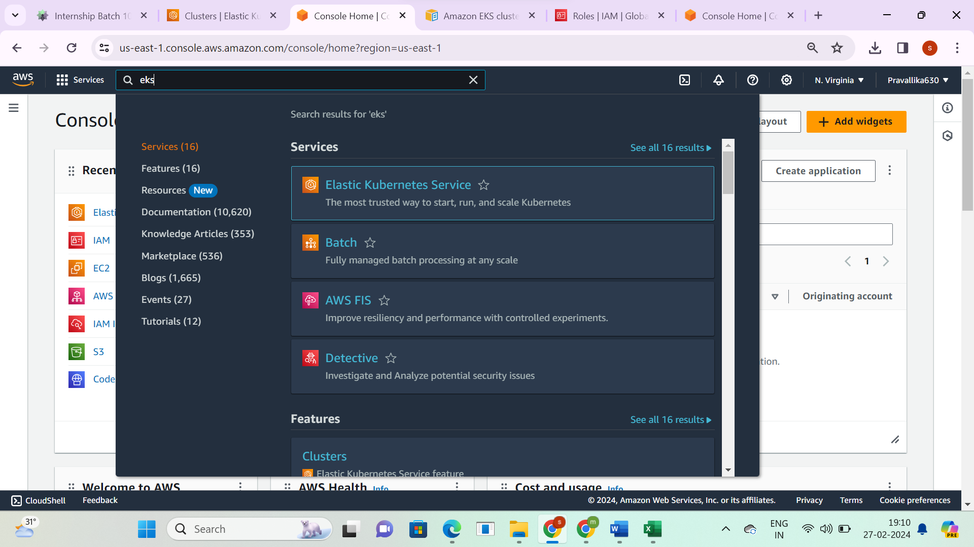

**Click on create cluster**

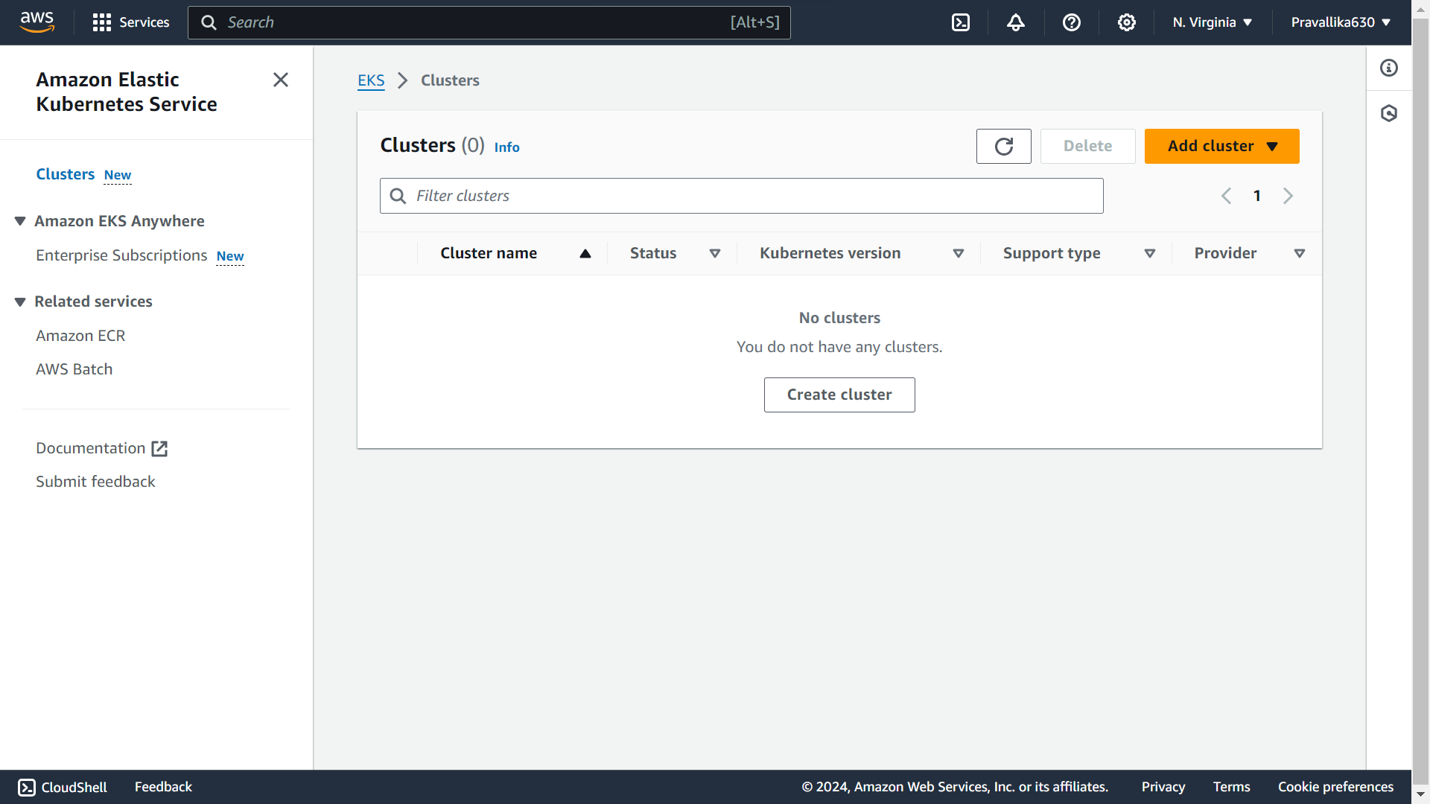 **Name-sricluster, version-1.28  
Select the created cluster service role**

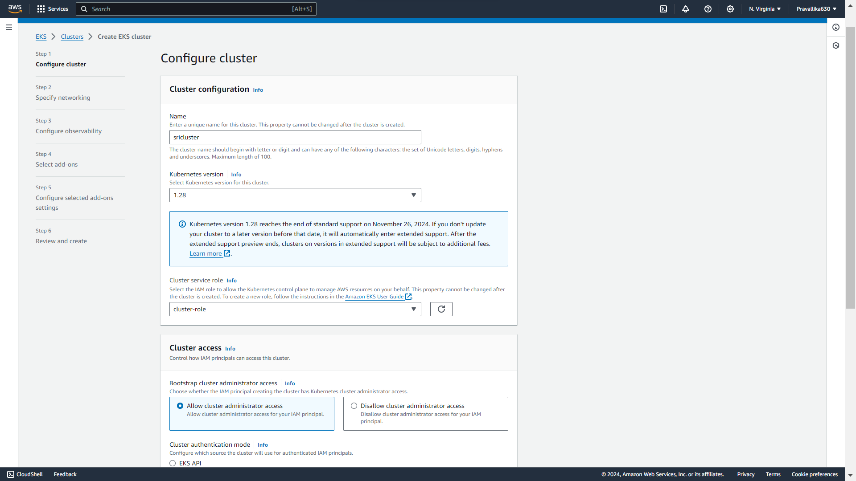

**Go to IAM and create role   
This is the created cluster service role**

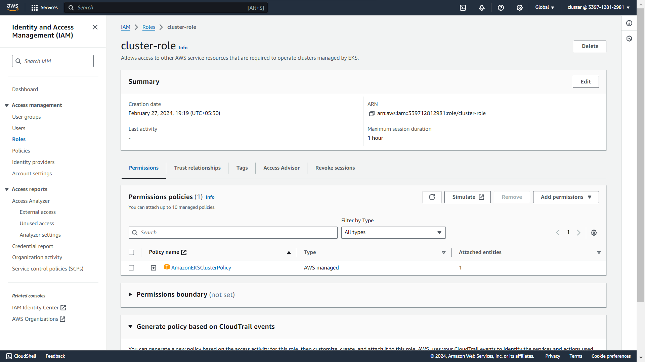

**Review and click on create cluster**

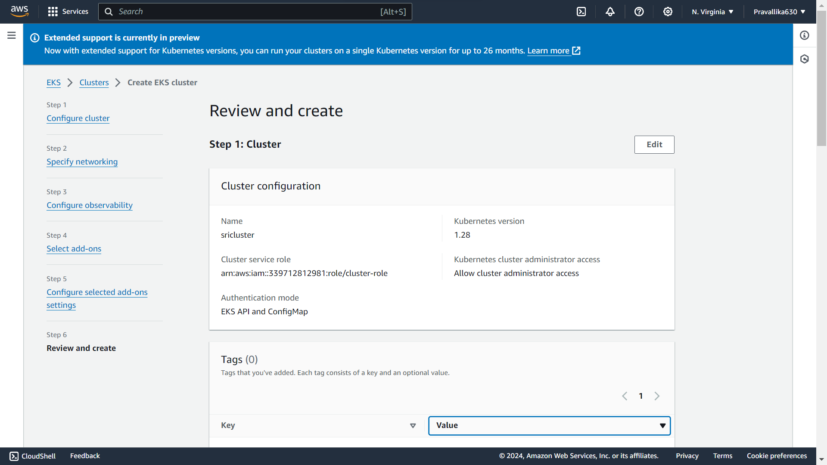

**Created cluster-1.28 version**

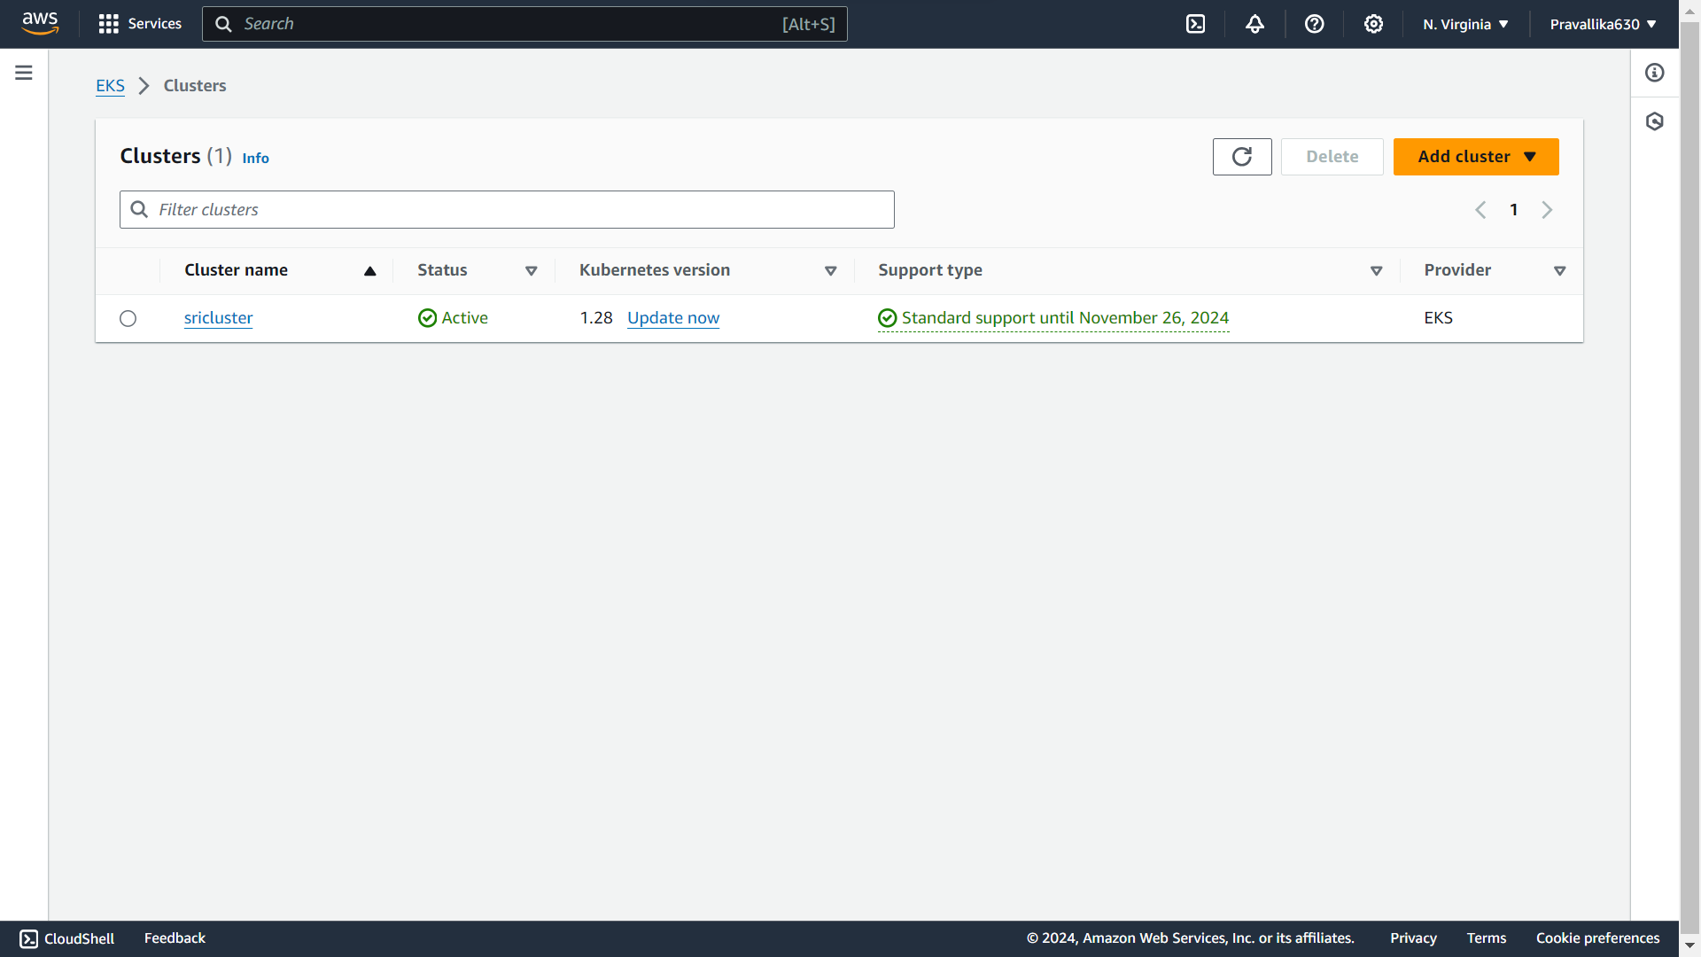

**Click on upgrade version**

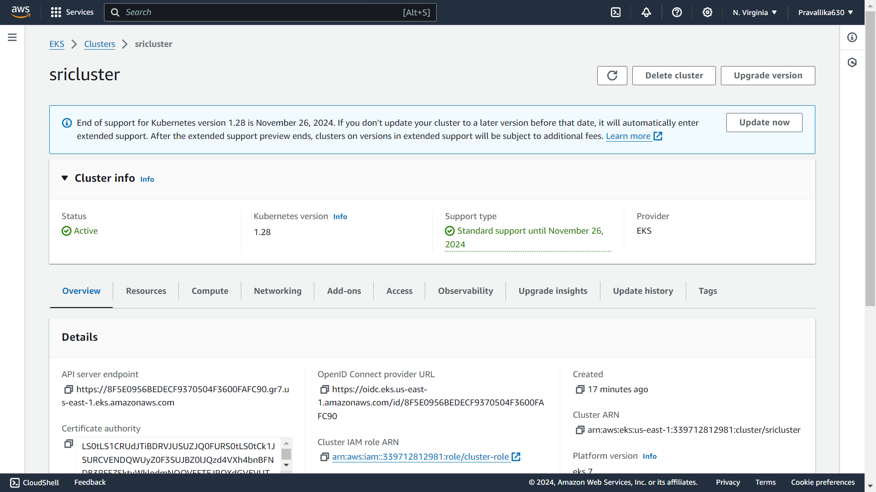

**Select the next updated version and click on update**

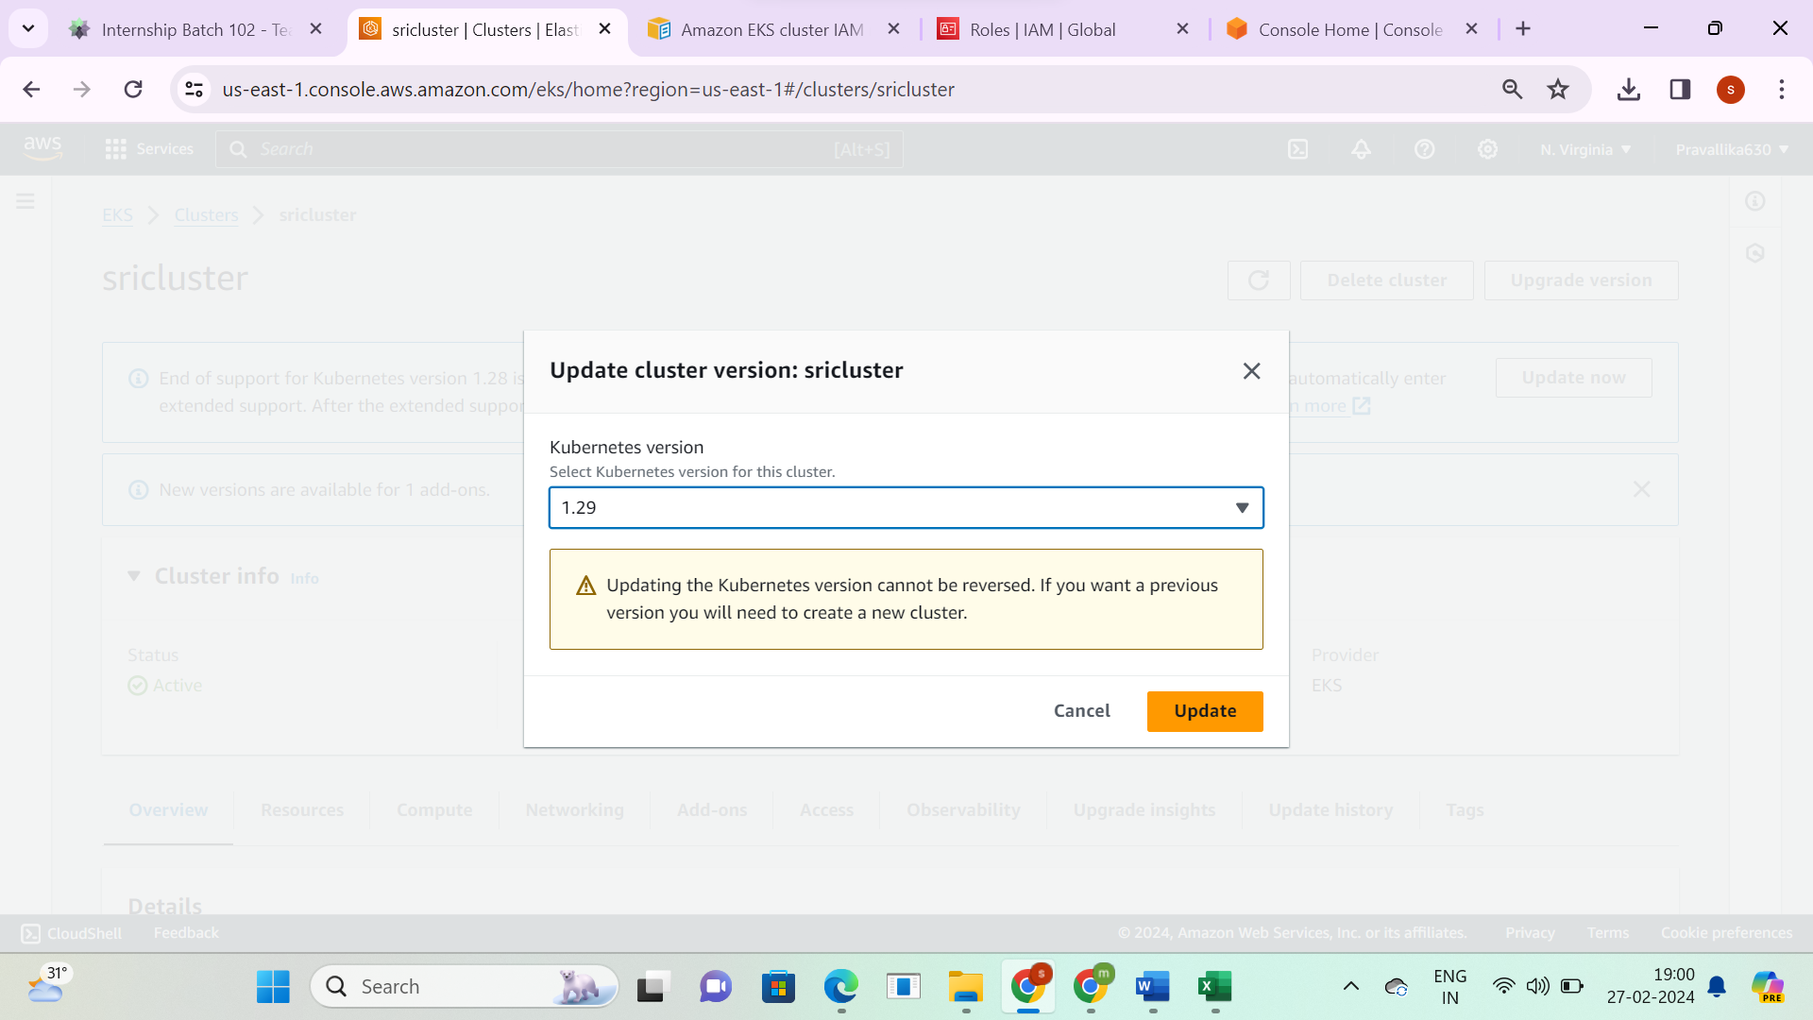

**Now the cluster version is upgraded from 1.28 to the next version 1.29**

